Stochastic numerical modeling for vibration behavior of an electrical machine stator with experimental quantification of response variability
Hussein Issa^{1,2,3*}, Jaafar Hallal^{2,3,4}, Mohammad Hammoud^{2,3}, Vincent Lanfranchi¹, Jean-Daniel Chazot¹, Frédéric Druesne¹
¹Sorbonne Universités, Université de Technologie de Compiègne, FRE UTC-CNRS 2012, Laboratoire Roberval, 60203 Compiègne, France
²SDM Research Group, Department of Mechanical Engineering, International University of Beirut, BIU,146404 Mazraa, Lebanon
³School of Engineering, Lebanese International University LIU, Bekaa, Lebanon
⁴Lebanese University, Faculty of Engineering, Beirut, Lebanon
*: Corresponding author: hussein.issa@utc.fr
Abstract
This paper presents a stochastic study to predict the effect of uncertainties on the natural frequencies and frequency response functions (FRFs) of an electrical motor stator with quantification of experimental variability. Experimental measurements are performed on 4 theoretical identical stators in order to quantify the response variability. A finite element analysis is conducted; 8-node hexahedral element is used for modeling the stator as linear homogeneous solid model with orthotropic properties, and several materials random parameters as well as different variability levels are considered. The Monte Carlo simulation (MCS) used to evaluate the variability of natural frequencies and FRFs. The uncertainties propagation is discussed for the different output variability levels. A comparison between experimental and numerical variability is also presented. The general trends of the experimentally observed variability, showed a negligible variability for natural frequencies. But for FRFs, as for numerical results, a high variability is obtained.
Keywords: stochastic modeling / stator vibration / experimental variability / uncertain material properties / Monte Carlo simulation

Nomenclature

C = Elasticity matrix
CoV = Coefficient of variation
$E_{L}$ = Longitudinal Young’s modulus
$E_{T}$ = Transverse Young’s modulus
f = Natural frequency
FRF = Frequency response function
$G_{LT}$ = Shear modulus
H = Transfer matrix
K = Stiffness matrix
M = Mass matrix
MCS = Monte Carlo simulation
$n_{t}$ = Number of random trials
T = Transpose
U = Displacement vector
$ν_{LT}$ = Poisson’s ratio
$ω$ = Angular frequency
$\frac{ΔF}{F}$ = Relative difference in natural frequencies
$ΔFRF$ = Difference in FRF amplitudes
$ϕ$ = Eigen mode
$Փ$ = Modal matrix
$θ$ = Perturbed case
- Introduction
Given the scope of electric machines interest, in particular recently in automotive industry, the understanding and thus the control of their vibration behavior is a challenging research issue today. Uncertainties in design parameters, induced due to manufacturing process, are affecting the vibrational behavior of the machine. Two types of parameters can be distinguished. The first type gathers all the parameters related to the material properties such as density and elastic modulus. The second type is related to the geometrical parameters and assembling aspects. Therefore, it is necessary to take into account uncertainties in the analysis of the dynamic behavior.
Deterministic methods are not sufficient to simulate the vibration response if the model becomes stochastic. The main goal of a non-deterministic analysis is to evaluate accurately the statistical quantities of a mechanical system: mean value, standard deviation, coefficient of variation and probability density function. Probabilistic approaches are often used to propagate uncertainties in the model. For industrial applications, vibration variability was studied by Kompella and Bernhard [1], Adhikari and Manohar [2], Soize [3], Arnoult et al.[4], Yin et al. [5], Druesne et al. [6-7], and Adhikari et al. [8]. For the non-deterministic case, several methods have been developed such as generalized polynomial chaos [9 - 11], Bayesian method [12], the first order and second order perturbation approaches [13, 14]. An overview of several stochastic methods is available in [15].Among all the probabilistic methods, Monte Carlo simulation (MCS) remains the reference method. This non-intrusive and robust method consists of performing a large number of trials in order to estimate the output variability, but it can be a time consuming method.
The objective of this paper is to evaluate the variability of natural frequencies and frequency response functions (FRFs) for an industrial stator from experimental and numerical points of view. First, the laminated structure is presented and the response variability is quantified experimentally on a set of stators in section 2. The numerical modeling of the stator for vibration response is developed for nominal and stochastic cases in section 3. In section 4, the MCS method is applied to the model to quantify the variability of natural frequencies and FRFs. Then, a comparison between experimental and numerical results is presented in section 5.

Experimental setting and variability of vibration response

  - Laminated structure and experimental procedure
The vibration experiments are performed on a stator of 48 teeth related to industrial electric motor provided by NIDEC Leroy-Somer Company. The stator used in this paper is presented in Figure 1(a) and it is composed of 370 sheets of thickness 650$μm$ made from M400 – 50A steel. The stator is of 240 mm length, 135 mm outer radius and 82.5 mm inner radius. The laminated structure is composed of 5 packets with different number of sheets oriented by 90° between successive packets. This set of sheets is held by eight staples to insure that no delamination or sliding will occur.
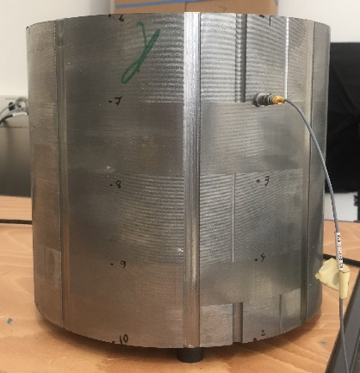(a) | 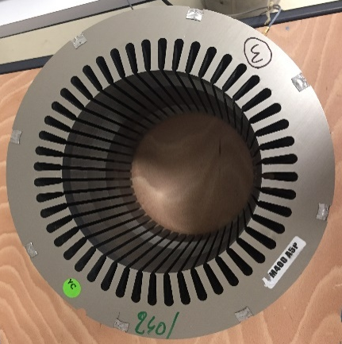(b) | 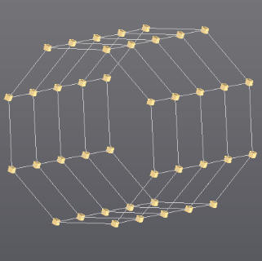(c)
Figure 1: (a) (b) stator in experimental setup, (c) experimental mesh with 40 nodes
For vibration measurements, the well-chosen procedure depends mainly on the proper instruments suitable for the targeted structure. Several instruments are used, such that laser scanning vibrometer, video magnification and accelerometers. As shown in figure 1, the stator is placed on 3 rubber stables to approach, as much as possible, the free-free boundary conditions. Figure 1(c) shows the generated experimental mesh of 120 degrees of freedom and 40 nodes. FRFs are measured by accelometer after radial excitation by the mean of an impact hammer. Moreover, repeatability of experiments is investigated to minimize measurement uncertainties where several measurements of FRFs are carried out for the stator.
  - Experimentally observed variability of several theoretical identical stators
The manufacturing of stators made of steel sheets induces uncertainties in material properties, leading to variability of responses. In order to evaluate this variability, four theoretically identical laminated structures are tested experimentally.
Table 1: Statistical quantities of natural frequencies for the first 4 experimental modes
Frequency | Mode | Mean values  (Hz) | CoV(f)  (%)
1 | (2,0) | 931.8 | 0.55
2 | (3,0) | 2434.7 | 0.142
3 | (4,0) | 4219.3 | 0.22
4 | (0,0) | 5764.1 | 0.138

Table 1 presents the experimental statistical quantities for natural frequencies expressed by mean values and output coefficient of variation CoV. The output variability obtained is less than 1% which considered very low. This means that the variability is negligible for first 4 natural frequencies from experimental point of view. Figure 3 shows the first 4 experimental mode shapes. It is classed by considering ($i,j$) where i is the mode order in the circumferential direction and j is the mode order in the axial direction. The same mode shapes are obtained for the 4 stators, which highlights a modal stability. Figure 4 shows the experimental FRFs of the 4 tested theoretically identical stators. This figure confirms that the variability at peaks, which represent the natural frequencies, is negligible. However, it shows a high level of variability that can reach 143% around the third peaks at 4219 Hz.
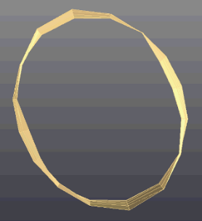(a) Mode (2,0) | 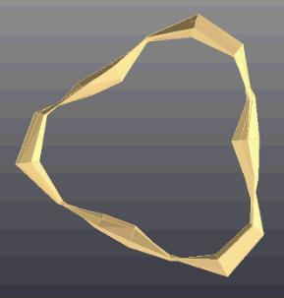(b) Mode (3,0) | 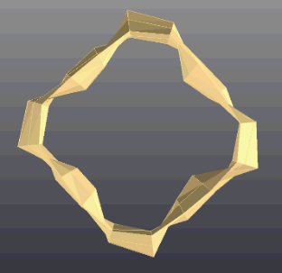(c) Mode (4,0) | 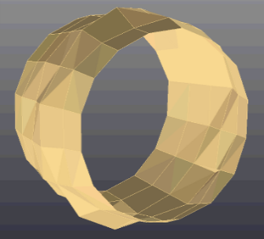(d) Mode (0,0)

Figure 3: First four experimental mode shapes of the stator

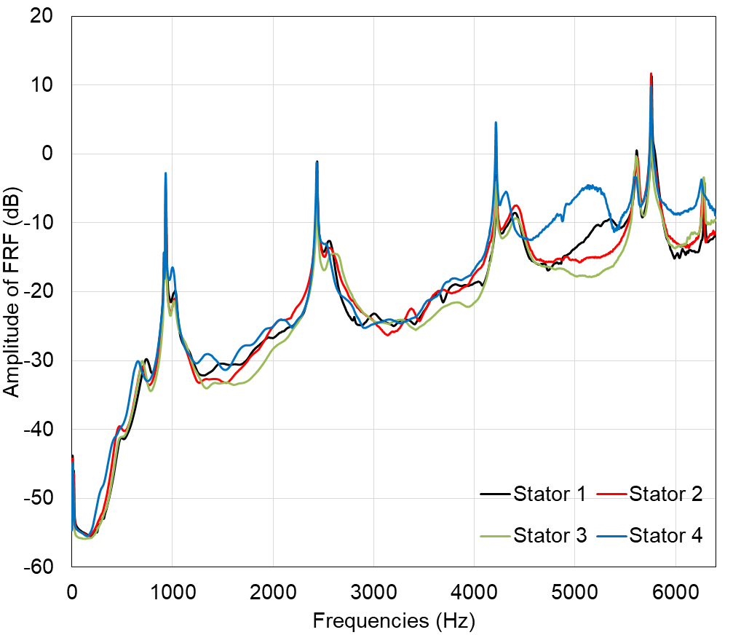
Figure 4: Experimental FRFs of the 4 stators

Nominal and stochastic modeling of the laminated structure for vibration response
  - Nominal modeling
The stator with the dimension presented in section 2.1 is considered as a 3D geometrical model in order to calculate all the mode shapes calculated experimentally. As the structure is a stack of sheets, the constitutive material is considered linear homogeneous with orthotropic properties. For a given point on the structure, the elasticity matrix $C$ is described by the Hook’s law$σ=Cε$, where $σ$is the stress tensor and $ε$ is the strain tensor. The elasticity matrix$C$ is considered transversely isotropic and expressed as:
$$C= \left[\begin{matrix}{\left(1-ν_{TT}^{2}\right)}/{{(E}_{T}^{2}Δ)} & {ν_{LT}\left(1-ν_{TT}\right)}/{{(E}_{T}^{2}Δ)} & {ν_{LT}\left(1-ν_{TT}\right)}/{{(E}_{T}^{2}Δ)} & 0 & 0 & 0 \\ & {\left(1-ν_{TT}^{2}\right)}/{\left(E_{T}E_{L}Δ\right)} & {\left(ν_{TT}-ν_{LT}^{2}\right)}/{\left(E_{T}E_{L}Δ\right)} & 0 & 0 & 0 \\ & & {\left(1-ν_{LT}^{2}\right)}/{\left(E_{T}E_{L}Δ\right)} & 0 & 0 & 0 \\ & sym & & 2G_{TT} & 0 & 0 \\ & & & & 2G_{LT} & 0 \\ & & & & & 2G_{LT}\end{matrix}\right]\left(1\right)$$
with $Δ=(1-2ν_{LT}^{2}- ν_{TT}^{2}-2ν_{LT}^{2}ν_{TT})/{(E}_{L}{E_{T}}^{2})$.
The characteristics of the elastic behavior of the stator includes: the Young's modulus $E_{L}$ in the stacking direction (longitudinal), the Young's modulus ${ E}_{T}$ in the transverse direction, the Poisson's ratio $ν_{TT}$ that corresponds to a contraction in a radial direction when an extension is applied in the other radial direction, the Poisson's ratio $ν_{LT}$ that corresponds to a contraction in a radial direction when an extension is applied in the stacking direction and the shear modulus $G_{LT}$ between the longitudinal direction and a transverse direction.

  - Stochastic modeling of the vibration behavior
For the finite element calculation of natural frequencies and FRFs, the displacement field is discretized by using standard polynomial shape functions. In the deterministic case, the equation of motion for free vibration is expressed by:
$K_{0}U_{0}$=$ω_{0}^{2}M_{0}U_{0}$ (2)
Subscript $0$ defines the nominal case, $K_{0}$is the stiffness matrix, $M_{0}$ is the mass matrix, $ω_{0}^{2}$ is the eigenvalue and $U_{0}$ is the eigenvector.
By considering material random parameters, the elasticity stiffness and mass matrices becomes perturbed. The equation of motion is then expressed with $θ$ defining the perturbed case:
$K(θ)U(θ)=ω^{2}(θ)M(θ)U(θ)$ (3)
leading to perturbed eigenvalue and eigenvector.
For the perturbed Rayleigh quotient [6], the expression depends indeed on perturbed mode shapes:
$ω^{2}(θ)$= $\frac{ϕ^{T}(θ)K(θ)ϕ(θ)}{ϕ^{T}(θ)M(θ)ϕ(θ)}$ (4)
The equation of motion for forced vibration in the non-deterministic case of finite element dynamic analysis leads to the perturbed displacement using the modal superposition technique:
$U(θ)=Փ(θ){H(θ)Փ(θ)}^{T}F$ (5)
where F is the amplitude of the applied harmonic external force and $Փ(θ)$ is the perturbed modal matrix. The transfer matrix $H\left(θ\right)$ can be expressed as:
$H\left(θ\right)={[Փ{\left(θ\right)}^{T}\left(K\left(θ\right)-ω^{2}M\left(θ\right)\right)Փ\left(θ\right)]}^{-1}$ (6)
- Numerical simulations
  - Nominal mesh, natural frequencies and mode shapes
With finite element method, the stator is modeled using 8-node hexahedral element. Figure 5 shows the mesh containing 27600 nodes used following a mesh convergence study in the nominal configuration. This mesh is also adopted for the variability study according to the methodology proposed by Mahjudin et al. [16] and Yin et al. [17] which confirm that the optimal mesh found in the nominal configuration can be exploited to calculate the variability. Figure 6 presents the first 6 nominal mode shapes and their associated natural frequencies in the low frequency range between 1002 and 5732 Hz. The mode shape is classed by the same classification methodology presented in section 2.2.
Figure 5: Finite element mesh of the stator with 27600 nodes

Mode (2,0) – $f_{1}$=1002 Hz | Mode (2,1) - $f_{2}$=1366 Hz | Mode (3,0) - $f_{3}$=2655 Hz
Mode (3,1) - $f_{4}$=3163 Hz | Mode (4,0) - $f_{5}$=4671 Hz | Mode (0,0) - $f_{6}$=5732 Hz

Figure 6: First six nominal mode shapes and natural frequencies of the stator
  - Random parameters and Monte Carlo simulation
The material properties are here considered as random parameters. Nominal values of the transverse and longitudinal Young modulus, the Poisson ratio and the density are respectively $E_{T}$= 208.5 GPa, $E_{L}$= 180.5 GPa, $ν$= 0.3 and ρ= 7700 kg/m³.The random input parameters respected the truncated Gaussian distribution law with 3 coefficients of variation CoV = {5%, 10%, 15%} corresponding respectively to low, moderate and high level of variability. Monte Carlo simulation (MCS) is performed with a number of trials $n_{t}=200$ to evaluate the output variability of natural frequencies and FRFs.
    - MCS for natural frequencies
The statistical quantities of natural frequencies obtained from MCS are the mean value and the coefficient of variation (CoV). Table 2 presents the output variability levels of natural frequencies for different input CoVs. A first observation is that the output variability is always lower than the input variability. Also, it varies between radial modes ((2,0)…) and modes with axial deformations ((2,1)…), except for density where quasi linear relationship is obtained between input CoV and output variability. Among the parameters being studied, ρ and $E_{T}$ have an important impact on the natural frequencies of the stator. The effect of $ν_{LT}$ is low and can be considered as insignificant, while for${ E}_{L}$, its effect is considerable on the modes with axial deformations only. The highest output level of variability is obtained when the density is the single random parameter. When all the uncertain parameters are taken into account, the output variability level is reduced. From uncertainties propagation point of view, the increase in number of random variables can leads to a compensation phenomenon. The same mode shapes are observed for all random trials. A modal stability is obtained where the mode shapes remain certain. This meets the conclusion made in [7], that the mode shapes are weakly sensitive to random variability in a mechanical system.
Table 2: Coefficient of variation (%) for the first six frequencies calculated by MCS method with 3 input levels of variability
Random parameters | Input CoV | CoV($f_{1}$) | CoV($f_{2}$) | CoV($f_{3}$) | CoV($f_{4}$) | CoV($f_{5}$) | CoV($f_{6}$)
$$E_{T}$$ | 5% | 1.36 | 0.50 | 1.36 | 0.97 | 1.36 | 1.35
 | 10% | 2.79 | 1.12 | 2.79 | 1.96 | 2.79 | 2.70
 | 15% | 4.16 | 1.88 | 4.16 | 2.97 | 4.16 | 4.10
$$E_{L}$$ | 5% | 0.17 | 0.74 | 0.17 | 0.51 | 0.17 | 0.75
 | 10% | 0.34 | 1.48 | 0.34 | 1.02 | 0.34 | 1.59
 | 15% | 0.52 | 2.20 | 0.52 | 1.52 | 0.52 | 2.21
ρ | 5% | 2.49 | 2.49 | 2.49 | 2.49 | 2.49 | 2.49
 | 10% | 5.08 | 5.08 | 5.08 | 5.08 | 5.08 | 5.08
 | 15% | 7.88 | 7.88 | 7.88 | 7.88 | 7.88 | 7.88
$$ν_{LT}$$ | 5% | 0.36 | 0.23 | 0.36 | 0.23 | 0.36 | 0.36
 | 10% | 0.92 | 0.59 | 0.92 | 0.61 | 0.92 | 1.05
 | 15% | 1.30 | 0.64 | 1.10 | 0.71 | 1.10 | 1.90
$E_{T}$, $E_{L}$ | 5% | 1.52 | 1.10 | 1.53 | 1.40 | 1.50 | 1.60
 | 10% | 2.70 | 1.07 | 2.70 | 1.88 | 2.70 | 2.70
 | 15% | 4.10 | 1.79 | 4.10 | 2.88 | 4.10 | 4.05
$E_{T}$, $E_{L}$, ρ | 5% | 1.45 | 2.15 | 1.45 | 1.65 | 1.45 | 1.44
 | 10% | 2.24 | 3.37 | 2.24 | 2.54 | 2.19 | 2.15
 | 15% | 3.15 | 5.02 | 3.15 | 3.90 | 3.15 | 3.15

    - MCS for FRFs
The effects of material properties variability on FRFs are here investigated for the stator model. A certain excitation is applied using radial unit force. For the frequency range of interest, mean FRFs and 95% confidence intervals are reported in order to analyze the output variability. Globally, figure 7 shows that for the different random parameters studied ($E_{T}$, $E_{L}$ and ρ), the output level of variability is significant and increases as frequency increases. The vibration response is sensitive to all parameters but with various levels. The maximum effect is reported when considering the density as single random parameter. When the different parameters${ E}_{T}$, $E_{L}$ and ρ are considered as random together (figure 7 – e), the output level of variability is less than when studying ρ alone. Again, the compensation phenomenon is observed due to the increase in number of random variables.
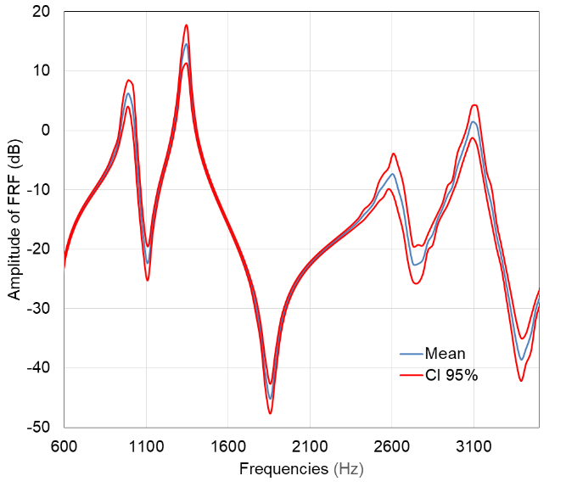(a) CoV($E_{T}$)=10% | 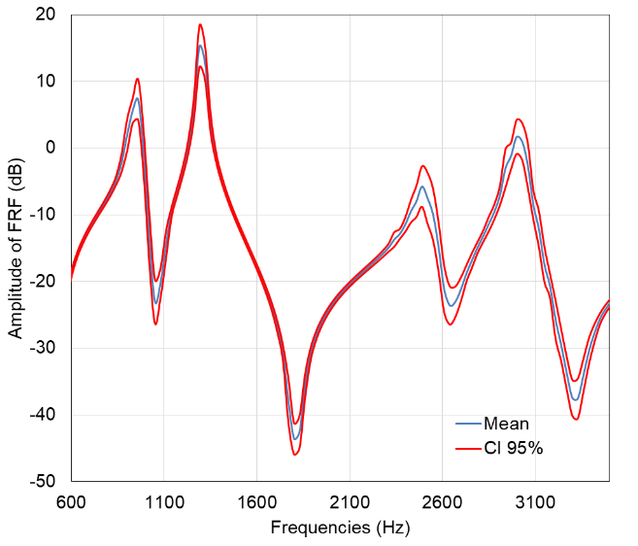(b) CoV($E_{L}$)=10%
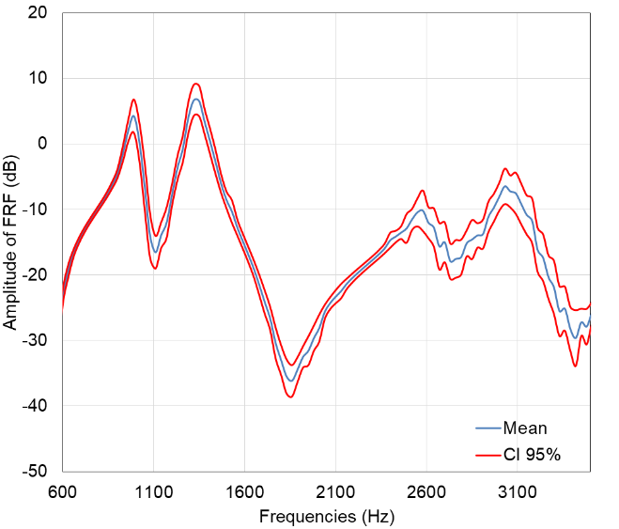(c) CoV(ρ)=10% | 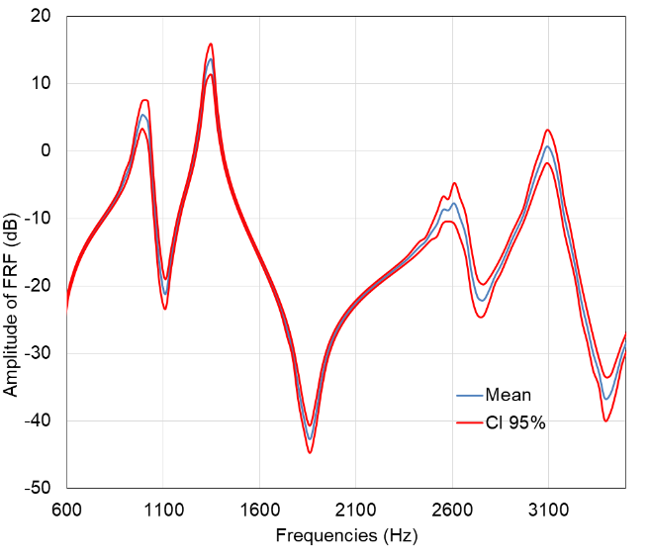(d) CoV($E_{T},E_{L}$)= 10%
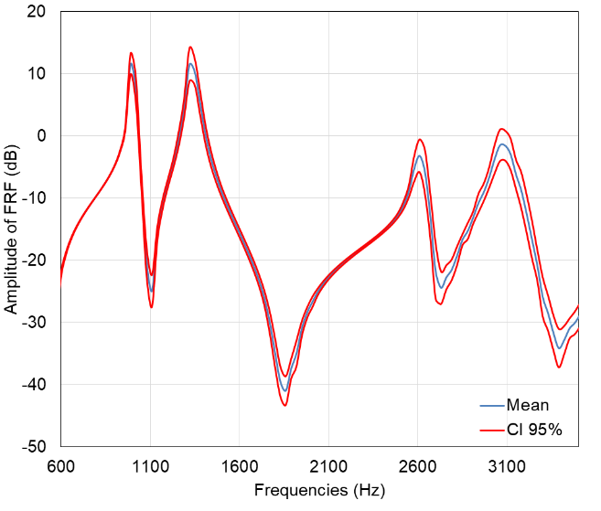
(e) CoV($E_{T},E_{L},ρ$)= 10%
Figure 7: Mean FRFs and 95% confidence interval of MCS for an input CoV=10% on material parameters

- Experimental and numerical comparison
For the numerical modeling, considering the 3 material parameters $E_{T},E_{L} and ρ$ as uncertain is the most realistic case because all parameters are possibly subjected to variability. So, a comparison between these corresponding numerical results and the experimental results is presented in this section. Table 4 shows the natural frequencies mean values obtained from the experimental measurements and from MCS for four modes (the same mean values are acquired for different variability levels in MCS). The relative difference$\frac{ΔF}{F}(f_{ex,i}, f_{MCS,j})$between mean values of natural frequencies of the experimental $i^{th}$ mode and MCS $j^{th}$ mode is also presented using equation (7). The results show a relative difference in the natural frequencies mean values between 1.45% and 9.32 % leading to a good correlation. Moreover, the coefficient of variation of natural frequencies from MCS listed in table 2 are greater than the experimental coefficient of variations of natural frequencies presented in table 1. This denotes that the levels of variability assigned in input (CoV = 5, 10, 15%) are certainly higher than the real variability of the material parameters.

Table 4: Mean values of natural frequencies for experimental and numerical results

Mode | Experimental  (Hz) | Numerical  (Hz) | $$\frac{ΔF}{F}$$  (%)
(2,0) | 931.8 | 979 | 5.1
(3,0) | 2434.7 | 2624 | 7.7
(4,0) | 4219.3 | 4612.7 | 9.3
(0,0) | 5764.1 | 5680 | 1.4

$\frac{ΔF}{F}(f_{ex,i}, f_{MCS,i})$= $\left|\frac{{f_{MCS,j}-f}_{ex,i}}{f_{ex,i}}\right|×100$ (7)
For FRFs, the numerical results concerning 3 material random parameters are also compared to the experimental results in terms of CoV in Tables 5. Coefficients of variation of amplitudes are calculated at each resonant peak. Again, the statistical numerical results are much higher than the statistical experimental results. But, it is noticed that for the 3 compared cases, the maximum variability is obtained at the 3rd mode (4, 0). This shows a great interest for this mode and a good correlation in the results. In general, numerical results are greater than experimental.
Table 5: Experimental and numerical coefficients of variation (%) of FRFs amplitudes for the four modes
Mode | Experimental | Numerical with CoV($E_{T}$, $E_{L}$, ρ)
 |  | 10% | 15%
(2,0) | 24.3 | 60 | 79
(3,0) | 44.7 | 102 | 157
(4,0) | 143.8 | 300 | 462
(0,0) | 66 | 147 | 183

- Conclusion
In this paper, the variability of natural frequencies and frequency response functions (FRFs) for an industrial stator is evaluated experimentally and numerically. Firstly, from the experimental point of view, the response variability is quantified on 4 theoretically identical stators. No significant variability is obtained for the first four natural frequencies in addition to a modal stability. But, the variability level of experimental FRFs is noticed to be significant. From the numerical point of view, the perturbed natural frequencies and FRFs are calculated for a 3D geometrical model using 8-node solid hexahedron elements with 27600 nodes in order to evaluate the effect of material properties variability on the vibrations of the structure. The uncertainty propagation is investigated using MCS with sufficient number of trials for several input levels of variability. For natural frequencies, the mean values and output CoVs are calculated. These statistical quantities lead to notice that the output level of variability is always less than the input. Mainly, density and transverse young’s modulus have significant effect on the natural frequency, in contrary to the effect of Poisson’s ratio which is insignificant. Also, compensation phenomenon is obtained when studying several parameters at the same time. For FRFs, the mean values and the 95% confidence intervals are calculated. All the parameters studied have relevant effects on FRFs. The levels of variability are noticed to be high and increase as the frequency increases. The maximum variability level is reported when considering density certain alone. Also, compensation phenomenon is obtained for FRFs.
A comparison between experimental and numerical statistical results is carried out. A significant difference is obtained for natural frequencies and FRFs. Globally, the input levels of variability assigned in the numerical model are certainly higher than the real variability of the material parameters.
In perspectives, we aim to link the variability quantified experimentally and the output variability of the numerical model to the uncertain input parameters of the stochastic numerical model.
Acknowledgment
The authors would like to acknowledge the NIDEC Leroy-Somer company for providing the industrial stators for the experimental tests.
References
[1]: M.S. Kompella, R.J. Bernhard, Variation of structural-acoustic characteristics of automotive vehicles, Noise Control Engineering Journal 44 (2) (1996) 93–98
[2]: S. Adhikari, C.S. Manohar, Dynamic analysis of framed structures with statistical uncertainties, International Journal for Numerical Methods in Engineering 44 (8) (1999) 1157–1178
[3]: C. Soize, A nonparametric model of random uncertainties for reduced matrix models in structural dynamics, Probabilistic Engineering Mechanics 15 (3) (2000) 277–294
[4]: E. Arnoult, P. Lardeur, L. Martini, The modal stability procedure for dynamic and linear finite element analysis with variability, Finite Element in Analysis and Design 47 (2011) 30–45
[5]: Q. Yin, F. Druesne, P. Lardeur, Probabilistic free vibration analysis of composite structures using the Modal Stability Procedure, Proceedings International Conference onNoise and Vibration Engineering ISMA, Leuven, Belgium, 2016, pp. 4255-4267
[6]: F. Druesne , J. Hallal , P. Lardeur , V. Lanfranchi , Modal stability procedure applied to variability in vibration from electromagnetic origin for an electric motor, Finite Element in Analysis and Design 122 (2016) 61–74
[7]: F. Druesne, M.B. Boubaker, P. Lardeur, Fast methods based on modal stability procedure to evaluate natural frequency variability for industrial shell-type structures, Finite Element in Analysis and Design 89 (2014) 93–106
[8]: S. Adhikari, A. Sarkar, Uncertainty in structural dynamics: Experimental validation of a Wishart random matrix model, Journal of Sound and Vibration 323(2009) 802-825
[9]: L. Nechak, S. Berger, E. Aubry, A polynomial chaos approach to the robust analysis of the dynamic behaviour of friction systems, European Journal of Mechanics – A/Solids 30 (2011) 594–607
[10]: E. Sarrouy, O. Dessombz, J.-J. Sinou, Stochastic analysis of the eigenvalue problem for mechanical systems using polynomial chaos expansion application to a finite element rotor, Journal of Vibration and Acoustics 134 (5) (2012) p. 051009
[11]: D. T. Kieu, B.Bergeot, M. L. Gobert, S. Berger, Stability analysis of a clutch system with uncertain parameters using sparse polynomial chaos expansions, Mechanics & Industry, 20 - 104(2019)
[12]: C. Soize, Bayesian posteriors of uncertainty quantification in computational structural dynamics for low-and medium-frequency ranges, Journal of Composite Structures 126(2013) 41-55
[13]: B. Cambou, Applications of first order uncertainty analysis in the finite element method in linear elasticity, in: Proceedings of the Second International Conference on Application of Statistics and Probability in Soil and Structural Mechanics, Aachen, Germany, 1975, pp. 67–87
[14]: M. Kaminski, Stochastic second order perturbation approach to the stress based finite element method, International Journal of Solids and Structures 38 (21) (2001) 3831–3852
[15]: S. Daouk, F. Louf, O. Dorival, L. Champaney, S. Audebert, Uncertainties in structural dynamics: overview and comparative analysis of methods, Mechanics & Industry, 16 (4) (2015)
[16]: M. Mahjudin, P. Lardeur, F. Druesne and I. Katili, Stochastic finite element analysis of plates with the Certain Generalized Stresses Method, Journal of Structural Safety 61(2016) 12-21
[17] Q. Yin, P. Lardeur and F. Druesne, Performances assessment of the Modal Stability Procedure for the probabilistic free vibration analysis of laminated composite structures, Journal of Composite Structures 203(2018) 474-485

